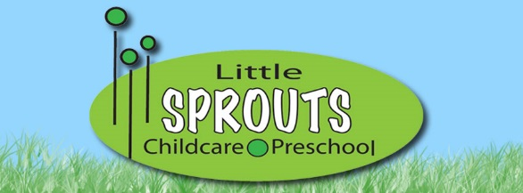
Baby/Daily Connect Frequently Asked Questions
How do I get Baby Connect set up for my personal use?
Go to http://www.baby-connect.com/ and click the “TRY IT NOW FREE WEB APPLICATION” button and follow the instructions.
Use the same email address that you have provided Little Sprouts with, either on your Emergency Contact or with a staff.
How do I get Baby Connect on my phone?
From the Baby Connect website, click on the download button and choose what kind of phone you have. Follow the directions from there. There is a $4.99 app fee
How can I see what is happening with my child throughout the day?
You can log-in to Baby Connect on the web or use the app on your phone.
What if I don’t have the chance to see what is happening throughout the day? How will I know about my child’s day?
Your child’s teacher will send an email at the end of the day, to the email address you provided, from Baby Connect that will summarize your child’s day. If this is an option you choose, please make sure to check your junk folder in case it gets sent there. All emails from Baby Connect should come from @littlesproutsmn.com address.
What happens when my child transitions to another room?
When your child moves to the next room, you need to add that room email address to your account and delete the previous one. For example: If your child is a Baby Bean, you have the address Babybeans@littlesproutsmn.com on your account. When they move to the Jumping Bean room, delete the Baby Bean email and add JumpingBeans@littlesproutsmn.com to your account so you can continue to see your child’s information. We will take care of the rest on our end!
To add or remove a classroom email:
-click on children profile
- click on the child’s name
- under ‘caregivers’, add the new email, and delete the old one

If you have any other questions or need assistance with Baby Connect, please speak with one of the Little Sprouts teachers!

