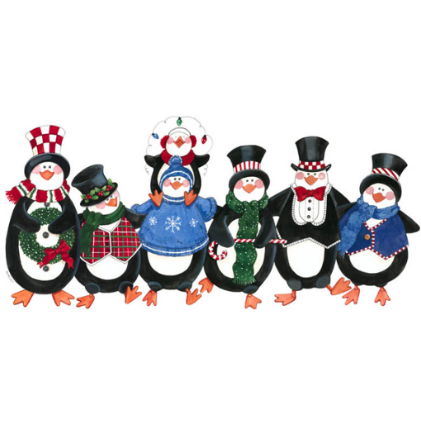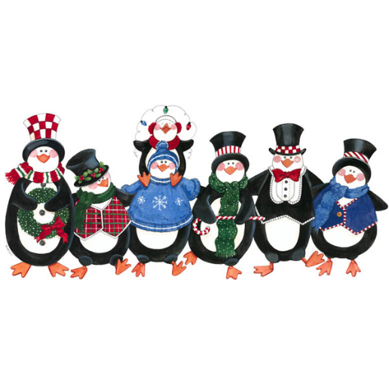Special Events at Tiny Sprouts

January 2020

*In the Winter*

|  |  |  |  |  |
| --- | --- | --- | --- | --- |
| Monday | Tuesday | Wednesday | Thursday | Friday |
|  |  | **1**  **Center Closed** | **2** | **3** |
| **6** | **7** | **8**  **Bubble Bath Day!**  **Celebrate with water play and bubbles** | **9** | **10** |
| **13**  **National Rubber Duckie Day**  **Celebrate by listening Sesame Street’s “Rubber Duckie”** | **14** | **15**  **National Bagel Day**  **Bagels for Breakfast** | **16** | **17** |
| **26**  **Happy Birthday**  **Miss Danielle**  **Martin Luther King Jr Day** | **21** | **22** | **23**  **Happy 2nd**  **Anniversary**  **Miss Kelsey!** | **24** |
| **27**  **Bubble Wrap Appreciation Day**  **Sensory Play with Bubble Wrap** | **28** | **29** | 30 | **31** |

Special Events at Tiny Sprouts

February 2020

*Healthy Bodies*

|  |  |  |  |  |
| --- | --- | --- | --- | --- |
| Monday | Tuesday | Wednesday | Thursday | Friday |
| **3** | **4** | **5** | **6** | **7** |
| **10**  **Love for the Home Team!**  **C:\Users\TinyS\AppData\Local\Microsoft\Windows\INetCache\Content.MSO\FBF8F538.tmp**  **Wear Your Favorite Sports Team Gear** | **11**  **Be a Hero!**  **Dress Like Your Favorite Superhero** | **12**  **Show Your Love for Comfort!**  **Wear your comfiest outfit!** | **13**  **Peace & Love!**  **Wear your tie dye and Hippie attire** | **14**  **Happy Valentine’s Day!**  **Wear Red, White and Pink** |
| Image result for professional development day clipart**17**  **Center Closed** | **18** | **19** | **20** | **21**  **Happy Birthday Ms. Sabrina**  **(2-22)** |
| **24** | **25**  **Pancakes for Breakfast** | **26**  Image result for once upon a time clipart**Tell a Fairytale Day!** | **27** | **28** |

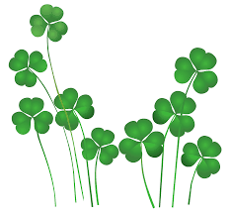 Special Events at Tiny Sprouts

March 2020

*My Imagination*

|  |  |  |  |  |
| --- | --- | --- | --- | --- |
| Monday | Tuesday | Wednesday | Thursday | Friday |
| **2**  **\*Special Birthday Snack** | Image result for dr seuss birthday**3**  **Fox in socks Day!**  Image result for fox in socks  **Wear your**  **mitch-match**  **crazy socks!** | **4**  **Wacky Wednesday!**  **Wear your wackiest hair**  **& clothes!**  **ANYTHING GOES!** | **5**  **Cat in the Hat day!**  **Wear your favorite hat!**  http://2.bp.blogspot.com/-FLp9QReC-ac/T0MKPDHeDLI/AAAAAAAAA9A/8IYCR0g8jEk/s1600/hathat_MT.png | [https://tse1.mm.bing.net/th?&id=OIP.M007025f491c2b86a068b7799fa9c505ao0&w=300&h=150&c=0&pid=1.9&rs=0&p=0&r=0](https://www.bing.com/images/search?q=red+Birthday+banner+clip+art&view=detailv2&&id=450487C877FFEC538F34CD6206216315F5FB4302&selectedIndex=11&ccid=AHAl9JHC&simid=608048584489242376&thid=OIP.M007025f491c2b86a068b7799fa9c505ao0)**6**  **Dr. Seuss Movie &**  **Pajama Day!**  Employee Appreciation Day!Image result for celebration clipart |
| **9** | **10** | **11** | **12** | **13**  **Happy 2nd Anniversary Miss Becky!** |
| **16** | **17**  **St. Patrick’s Day**  Wear green &/or your favorite St. Patrick’s gear! | **18** | Related image**19**  **Happy Birthday**  **Miss Elise!** | **20** |
| **23**  Related image**Chip and Dip Potluck**  **National Chip & Dip Day** | Image result for celebration clipart**24**  **Happy 5th Anniversary**  **Miss Nicole!** | **25** | **26** | **27** |
| Image result for celebration clipart**30**  **Happy 3rd Anniversary**  **Miss Mindy!** | **31** |  |  |  |

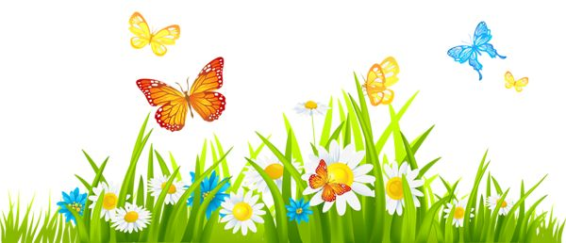 Special Events at Tiny Sprouts

April 2020

*In the Spring*

|  |  |  |  |  |
| --- | --- | --- | --- | --- |
| Monday | Tuesday | Wednesday | Thursday | Friday |
|  |  | **1**  **April Fool’s Day!**  Wear Something Silly!Image result for april fools clipart | **2** | **3** |
| **6** | **7** | **8** | **9** | **10**  **Tiny Sprouts Closed** |
| **13**  Week if the Young Child  **Music Monday**  Sing, Dance, Celebrate & Learn  [https://tse1.mm.bing.net/th?&id=OIP.M92ce73f036125953d806bb2f75bcd2ebH0&w=300&h=280&c=0&pid=1.9&rs=0&p=0&r=0](https://www.bing.com/images/search?q=music+notes+clip+art&view=detailv2&&id=214BA6A0250EAEEC37E6BBEA005EC9C3D0868873&selectedIndex=12&ccid=ks5z8DYS&simid=608055765682490552&thid=OIP.M92ce73f036125953d806bb2f75bcd2ebH0) | **14**  **Tasty Tuesday**  Healthy Eating & Fitness | **15**  **Work Together Wednesday**  Image result for learn together clipartWork, Build & Learn Together | **16**  **Artsy Thursday**  Image result for create clipartThink, Solve & Create | **17**  **Family Friday**  Join Us for a Snack  **3:00pm**  Image result for family clip art**`** |
| **20**  Image result for earth day clipart**Earth Day** | **21** | **22** | **23** | **24** |
| **27** | **28** | **29** | **30**  **Hairstyle Appreciation Day!**  **Wear Crazy Hair to School!**  Image result for crazy hair clipart |  |