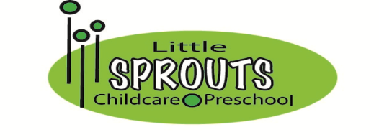
December 16th, 2019
Dear Little Sprouts Families,
It’s time for the winter/spring activity fee for 2020. This fee will cover activities for January, February, March, and April. We have several fun in-house activities, events and preschool field trip planned! Please check out our website for all the activity calendars.

Jumping Beans $15 per child
Pea Wees $15 per child
Tod Pods $15 per child
Mighty Tods $15 per child
Pea Pods $15 per child
Sweet Peas $15 per child
Mini Sprouts $15 per child
Kinder Sprouts $20 per child
Kinder Peas $20 per child

Your payment will be done through automatic withdrawal on Friday, December 27th.
If you would like to make other payment arrangements or have any questions, please email us at Daniellejoyce@littlesproutsmn.com .

Thank you,

Danielle Joyce, Tara Jarosiewicz, Lacy Novak and Stacy Fritsche

