Monday | Tuesday | Wednesday | Thursday | Friday
2  CENTER  CLOSED | 3 | 4 | 5 | 6  Happy Grandparents Day!  Grandparents Day Snack  3:30pm  Happy Birthday Ashli!!
9  Happy Birthday Jenna!!  (8th) | 10 | 11  Fantasy Corral Petting Zoo  9:00-11:00 | 12 | 13
16 | 17  Look out ridge  Kinder Sprouts & Kinder Peas  Leave 9:15  Return 11:30 | 18 | 19  Happy 2nd Anniversary Stephanie!! | 20  Happy Birthday Stacy!!
2323  23  Favorite color day! | 24  Favorite hat day! | 25  Favorite pajamas day  & movie day! | 26  Favorite toy/book day! | 27  Favorite sports  team day!
30

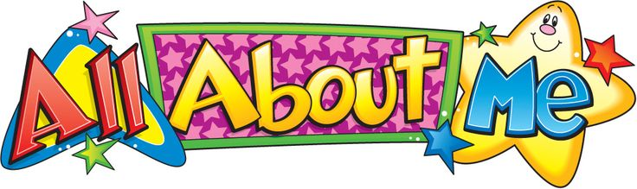
Special Events Calendar
September 2019
*All about me*

Special Events Calendar
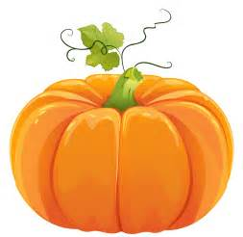
October 2019
*In the Fall*

Monday | Tuesday | Wednesday | Thursday | Friday
 | 1 | 22 | 3 | 4
7  Happy Birthday Lauren!!  (6th)  Fire Prevention week! | 8 | 9  Afton Apple Orchard  Kinder Sprouts & Kinder Peas  Leave 9:00  Return 11:00 | 10  Bring your favorite Halloween book! | 11  Trunk or Treat! 6:30pm
14  CLOSED  PROFESSIONAL  DEVELOPMENT DAY | 15  Country Sun Farm  Sweet Peas and Mini Sprouts  Leave 9:00  Return 11:00 | 16  Pumpkin  carving fun!  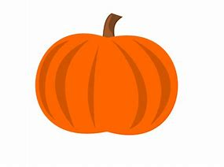 | 17  Wanda the Wacky Witch | 18
21 | 22 | 23 | 24 | 25  SPooky  Halloween  snack!
28 | 29  Happy 1st Anniversary Mika!! | 30 | 31  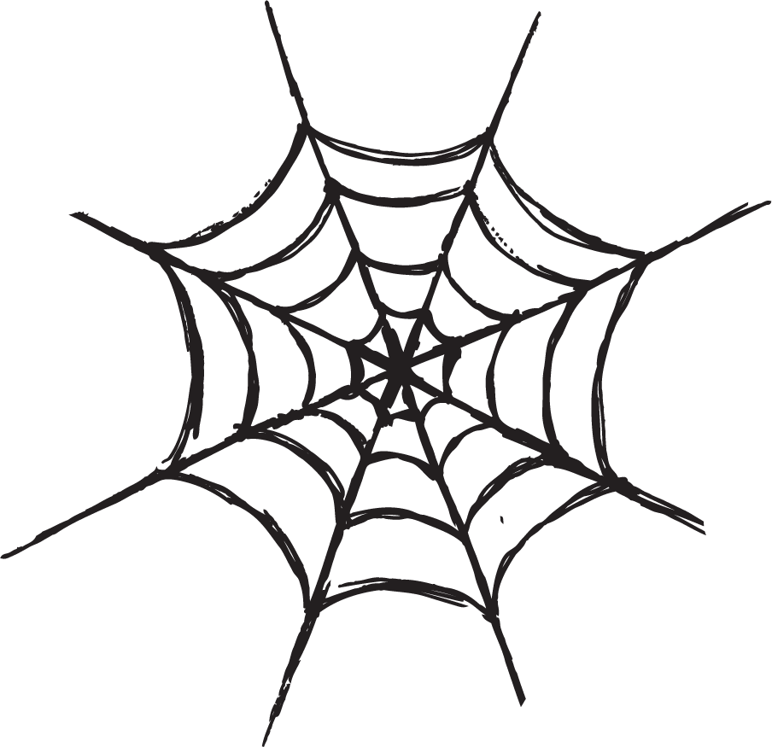  Halloween Party!  Wear your costume  to school!  Center closes early – 5pm
Special Events Calendar
November 2019
*My community*

Monday | Tuesday | Wednesday |  | Thursday | Friday
National Child Safety Protection Month |  |  |  |  | 1  Happy 3rd Anniversary Brittany!!
4 | 5 | 6 |  | 7  Visit from a Fire Fighter! | 8  Movie &  Pajama Day!
11  (New session) | 12  Visit from a Doctor! | 13 |  | 14 | 15
18 | 19  Fall Pictures | 20  Happy 2nd Anniversary Jordan S.!! | 21 |  | 22
25  Giving Trees  Displayed | 26 | 27  Thanksgiving  Day Snack  Please join us for  a special snack  3:30pm |  | 28  Center Closed  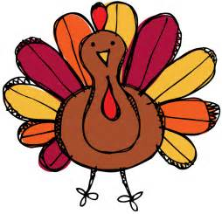  Happy Thanksgiving! | 29  Center Closed
Special Events Calendar
December 2019
*Holidays around the world*
Monday | Tuesday | Wednesday | Thursday | Friday
2  Santa’s List Day!  Write your list  for Santa! | 3 | 4  Visit from the  “Elf on the Shelf!”  9:00am | 5  Bring in your favorite holiday story book! | 6
9 | 10  7:00-9:00 & 3:00-5:30 | 11  7:00-9:00 & 3:00-5:30 | 12 | 13
16  Holiday Spirit Week!  Food drive! Bring a non-perishable item!  Wear a cozy flannel day! | 17  Wear your favorite Christmas sweater & Christmas socks day! | 18  Santa is coming to  Little Sprouts!  Wear your favorite  Holiday outfit  *Classroom gift opening* | 19  Wear your favorite  Holiday Headwear/Crazy holiday hair Day!  Happy Birthday Lacy!! | 20  Christmas pajama & movie day!
23 | 24  Center Closed | 25  Center Closed  Merry Christmas! | 26  Center Closed | 27  Happy 1st Anniversary Lauren !!
30  Happy Birthday Mika!!  (28th ) | 31  New Year’s Eve Day - Early Closing  6:30 a.m. to 12:00 p.m.

